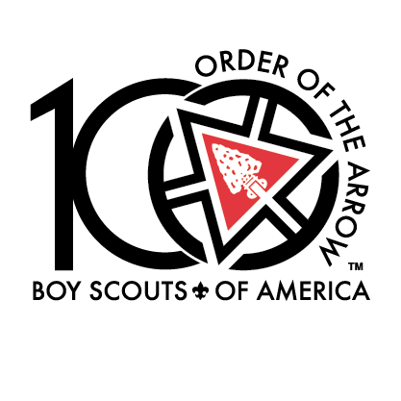 

## PRESS RELEASE

## Media Contact:

(Name)

(Phone)

(Cell phone)

(Email address)

**ArrowTour to Celebrate the 100th Anniversary of the**

**Boy Scouts of America’s National Honor Society – Order of the Arrow**

**(ININSERT CITY NAME, State – (Month, Day, Year)** – 2015 marks the Boy Scouts of America’s National Honor Society’s (Order of the Arrow) 100th anniversary. The Order of the Arrow (OA) and its members, “Arrowmen,” will commemorate this exciting anniversary milestone with a U.S., cross-country, tour to help reflect, connect and discover the OA’s past, present and future. ArrowTour will make 110 stops across the country during the summer of 2015, to give current and former OA members, Scout and adult volunteers and Scouting alumni a chance to be a part of the 100th anniversary celebration. The tour stops are free and open to the public. On **(Month, X, 2015)**, ArrowTour will be at **( <insert local stop name and address> from X:00 a.m. – X:00 p.m. )** “For almost 100 years, being a servant leader is what the Order of the Arrow has been all about,” said Alex Call, national chief of the Order of the Arrow. “It is our hope that ArrowTour will be an opportunity to tell the story of the Order of the Arrow by reflecting on our past and at the same time motivating others to give of themselves in service to others in the future.”

ArrowTour guests will have an opportunity to participate in a program that will include a show that recognizes the Order’s rich history and empowers participants to help shape the organization’s future. The tour stop also includes interactive exhibits with activities such as silk-screening and branding and challenge games. **(<insert additional local activities>).**

Participants will have a chance to meet some of the OA’s national youth leaders, and alumni can learn about the Scouting Alumni Association and local alumni efforts to supporting Scouting in our area. An exclusive ArrowTour trading post will carry ArrowTour and OA centennial merchandise for sale. More information about the ArrowTour routes and program can be found at http://arrowtour.oa-bsa.org. You can also keep up with the tour as it makes its way around the country by following @ArrowTour on Twitter.

As Scouting’s National Honor Society, the OA’s purpose is to recognize those Scouts who best exemplify the Scout Oath and Law in their daily lives and through that recognition cause others to conduct themselves in a way that warrants similar recognition; promote camping, responsible outdoor adventure, and environmental stewardship as essential components of every Scout’s experience, in the unit, year-round, and in summer camp; develop leaders with the willingness, character, spirit and ability to advance the activities of their units, our Brotherhood, Scouting, and ultimately our nation; crystallize the Scout habit of helpfulness into a life purpose of leadership in cheerful service to others.

The Order of the Arrow was founded by Dr. E. Urner Goodman and Carroll A. Edson in 1915 at the Treasure Island Camp of the Philadelphia Council, Boy Scouts of America. It became an official program experiment in 1922, and was approved as part of the Scouting program in 1934. In 1948, the OA, recognized as the BSA's national brotherhood of honor campers, became an official part of the Boy Scouts of America. In 1998, the Order of the Arrow became recognized as Scouting's National Honor Society when it expanded its reach beyond camping to include broader service to Scouting and the community.

# # #

**About Order of the Arrow**

For more than 99 years, the Order of the Arrow (OA) has recognized Scouts and Scouters who best exemplify the Scout Oath and Law in their daily lives. This recognition provides encouragement for others to live these ideals as well. Arrowmen are known for maintaining camping traditions and spirit, promoting year-round and long term resident camping and providing cheerful service to others. OA service, activities, adventures and training for youth and adults are models of quality leadership development and programming that enrich and help to extend Scouting to America's youth. 2015 marks the Order of the Arrow’s 100th anniversary.

**About the Boy Scouts of America**

The Boy Scouts of America prepares young people for life by providing the nation’s foremost youth program of character development and values-based leadership training. The Scouting organization is composed of 2.7 million youth members between the ages of 7 and 21, and more than a million volunteers, in local councils throughout the United States and its territories. For more information on the Boy Scouts of America, please visit [www.scouting.org](http://www.scouting.org).