2009 NATIONAL ORDER OF THE ARROW CONFERENCE  PERSONAL FINANCE TRACKER |  |  | 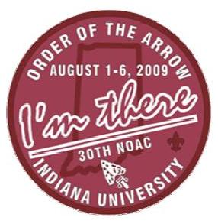  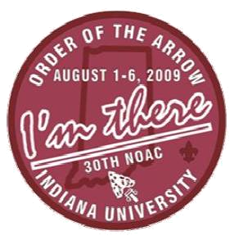
Name:  Personal Fundraising Goal: $  Today’s Date:  Date to be Completed by:
  Lodge
  Council
Date |  | Monetary Goal |  | Amount Raised |  | Still to Raise
 |  | $ | ( - ) |  | ( = )
 |  | $ | ( - ) |  | ( = )
 |  | $ | ( - ) |  | ( = )
 |  | $ | ( - ) |  | ( = )
 |  | $ | ( - ) |  | ( = )

How I plan to raise money: | .
  Project/Event |  | Amount I Raised
   | $
   | $
   | $
   | $
   | $
   | $
   | $
   | $
   | $
   | $
   | $
   | $
   | $
   | $
   | $
   | $
   | $
   | $

List of upcoming lodge fundraisers you can participate in: |  | Who to contact for assistance:  Lodge Adviser: _________________________  Phone Number: ________________________  Email Address: _________________________  Other: _______________________________  Phone Number: _______________________  Email Address: ________________________
Date: |  | Event: |  | Location:

